**1.**

An option gives the holder the right to do something, but the holder does not have to exercise this right, so the buyer have to pay a fee (called a premium) for this right. In forwards or futures, the two parties have committed themselves to do some action in the future.

**2.**

Profit from buying a European put option: option price = $5, strike price = $80

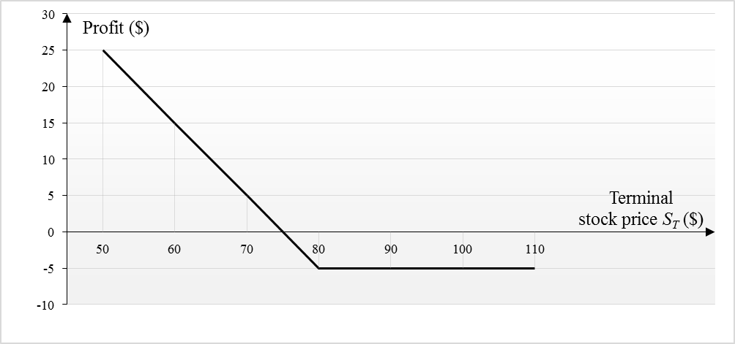

Profit from writing the same European put option: option price = $5, strike price = $80

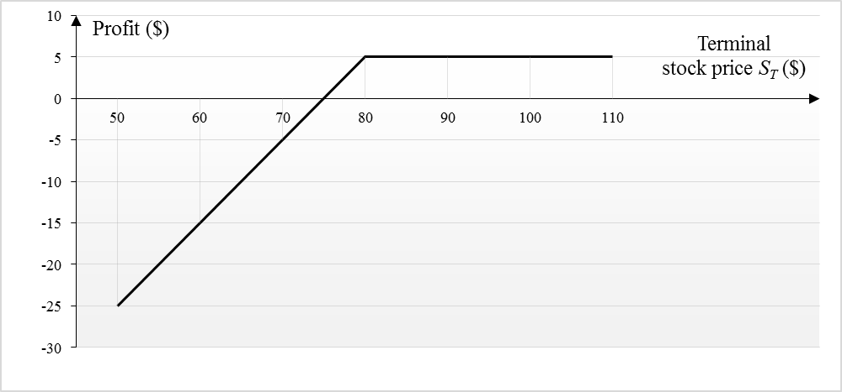

**3.**

**(a)**

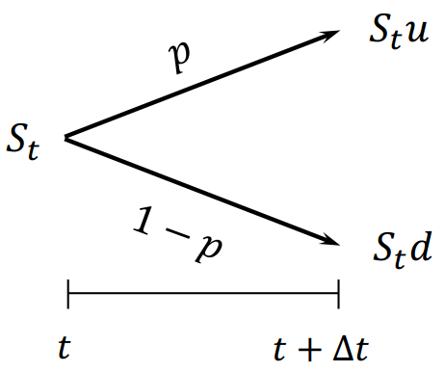

(1) Matching mean:

(2) Matching variance:

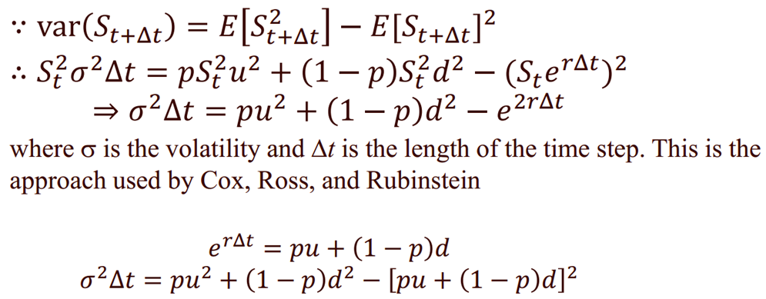

With and the assumption of or

**(b)**

,

,

,

Discount per term:

**4.**

**(a)**

,

**(b)**

**5.**

**(a)**

The convergence rate of Monte Carlo methods is , where N is number of paths. If 1000 paths lead to an accuracy of 0.1, then approximately paths will lead to an accuracy of 0.01.

**(b)**

Quasi Monte Carlo method is a method that operates in the same way as Monte Carlo method, but instead uses sequences of quasi-random numbers (Halton Sequences, Faure Sequences, SobolSequences…). This method has a probabilistic error of . Thus, it in practice is usually much faster than its theoretical bound.